SPAIN 2018 Health Forms Information

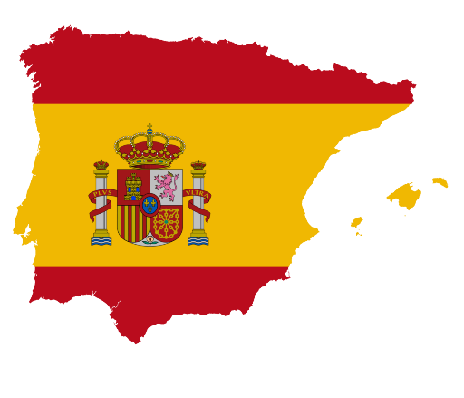

Hello Spain traveler and Family-

Attached is the health form for our upcoming trip to Spain. Please complete it accurately. Here are some tips and directions to help you.

* Make sure all contact information is correct and clearly written.
* All allergies should be listed especially food and bee stings.
* Medications – list medications that your child will be taking. *IF YOU WRITE IT ON THIS FORM, I WILL HAVE TO CARRY THESE MEDICATIONS AND DISPENSE AS DIRECTED.*
* Make sure all physician information is current and correct.
* Please photocopy your health insurance card and attach it to the bottom of page 1. Please use clear tape and have it completed before the meeting on October 11.
* Page two has places for both the student and guardian to sign. Please make sure that these are correctly done.*
* YES! Even chaperones should complete this form. It is the only thing medical personnel will have should you not be able to communicate with them yourself. I will not have to carry and dispense adult medications.

Thanks! I look forward to seeing you all at the **Trip Meeting on October 11 at 6PM!**